1. Create an employee table with following fields

Empno : Number(10)( primary key)

Ans: CREATE TABLE EMP(EMPNO NUMBER(4) PRIMARY KEY,ENAME VARCHAR(12),SALARY NUMBER(10),COMMISSION NUMBER(7) ,DEPTNO NUMBER(20));

INSERT VALUES: INSERT INTO EMP VALUES(&EMPNO,'&EMPNAME',&SALARY,&COMMISSION,&DEPTNO);

ANS:

Enter value for empno: 1

Enter value for empname: GAYATHRI

Enter value for salary: 20000

Enter value for commission: 60

Enter value for deptno: 3

old 1: INSERT INTO EMP VALUES(&EMPNO,'&EMPNAME',&SALARY,&COMMISSION,&DEPTNO)

new 1: INSERT INTO EMP VALUES(1,'GAYATHRI',20000,60,3)

1 row created.

DISPLAY ALL RECORDS

SELECT \* FROM EMP;

EMPNO ENAME SALARY COMMISSION DEPTNO

---------- ------------ ---------- ---------- ----------

2 GAYATHRI 32000 600 1

7 KUTTUZ 802 6 4

6 FIDHA 6028 6 9

1 GAYATHRI 20000 60 3

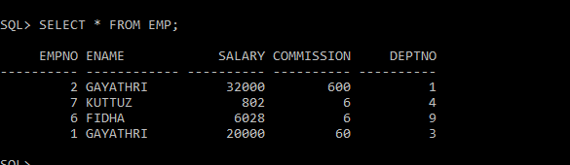

\*ALTER TABLE

ALTER TABLE EMP ADD(JOB VARCHAR(20));

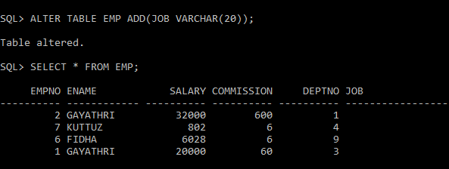

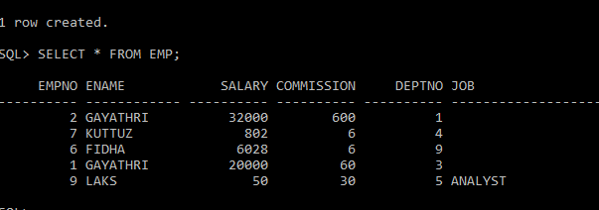

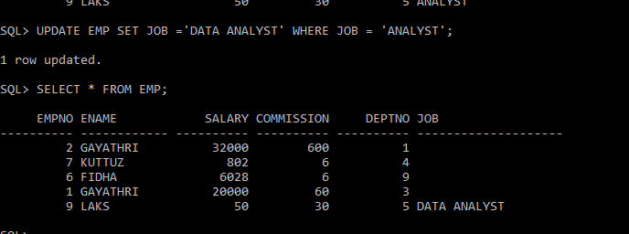

ALTER TABLE:

